**CHAPTER 6**

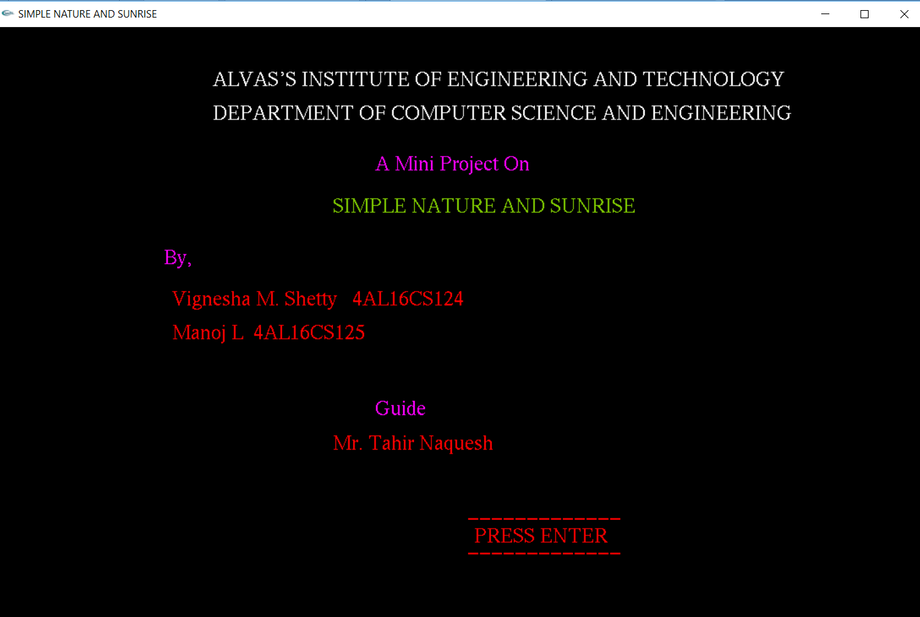**SNAPSHOTS**

**Fig.6.1 Main Menu**

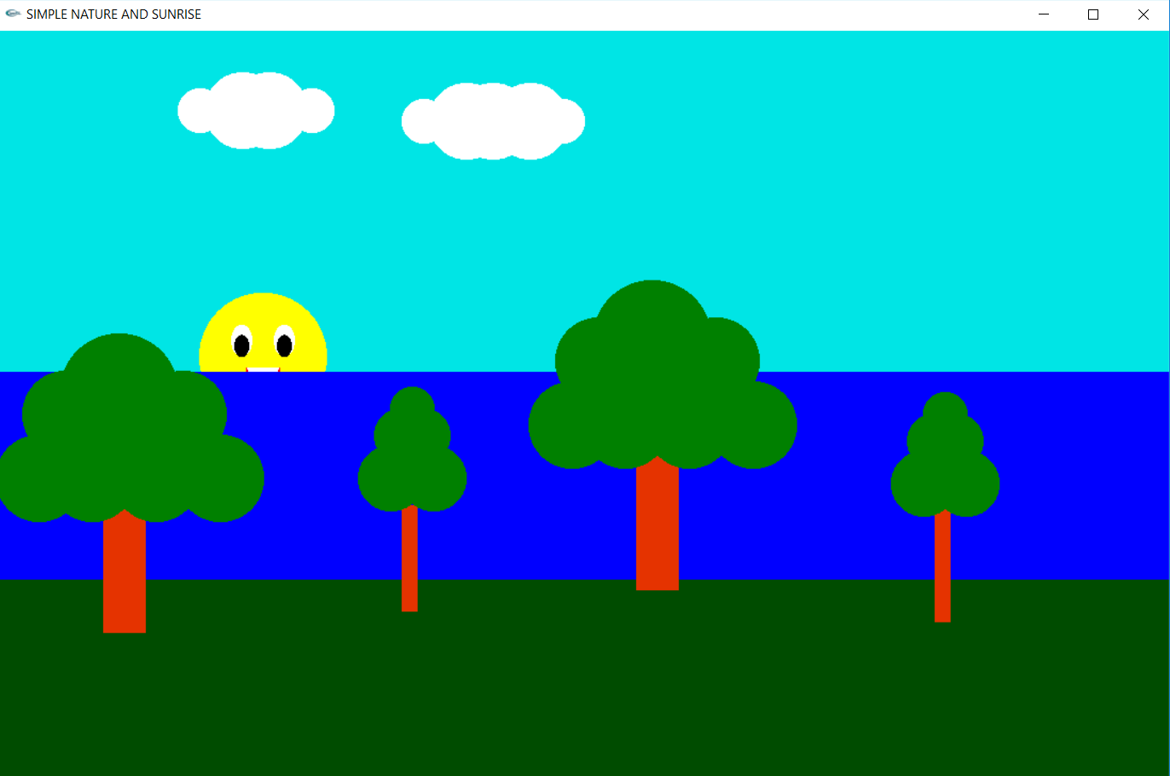

**Fig.6.2 Day Mode at the time of Sunrise**

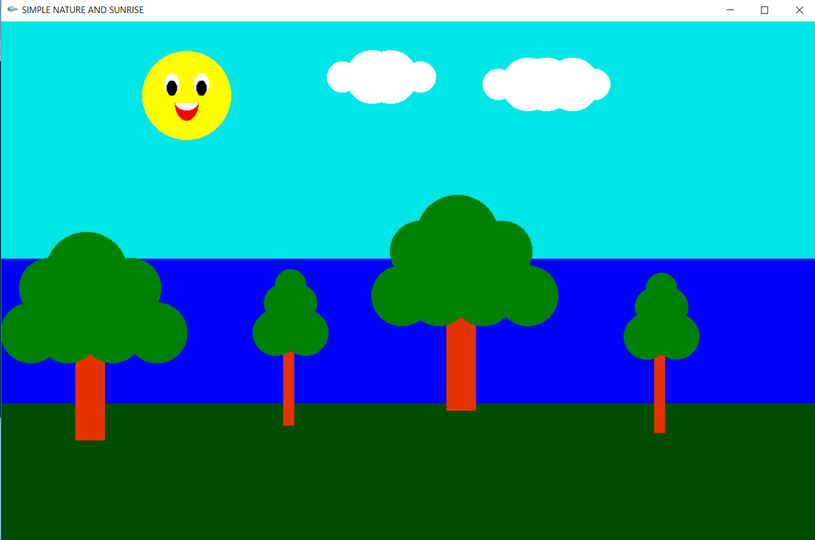

**Fig.6.3 Day Mode after Sunrise**

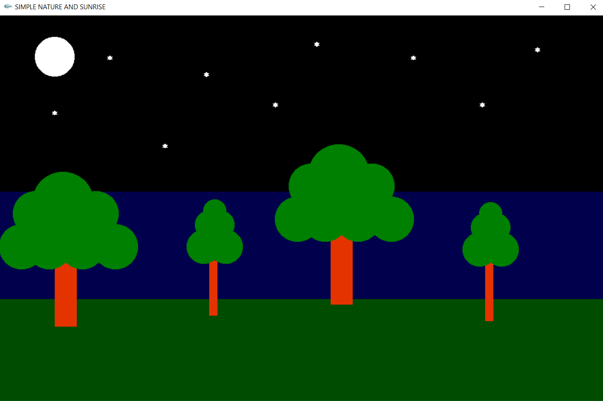

**Fig.6.4 Night Mode**

**Fig.6.5 Flying Birds**

